Academy Data Analysis

* The size of the school has a big impact on the overall scores of the student body.

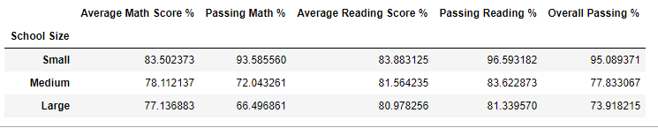

Based on these results, you can see that as the size of the school increases, the average math and reading scores both go down and the number of students who end up passing either subject great decreases as well. Student in a small school regardless of how much the school spends per student have the greatest impact on the students ability to pass or fail math and reading.

* Reading seems to be a much better subject for the students in the district as 85.8% of them pass while they struggle in math because only 75.0% of them pass it.



The averages of the math and reading scores and passing percentages seem to be the same for all grades as the people who fail the previous year, fail to move forward into the next grade. Its evident by the fact that as the grades go higher, the number of students in each grade tend to decrease meaning the failed students don’t move on and the same percentage of students tend to fail every year.

* Charter schools vs. district schools also makes a big difference in a student’s math and reading performance.

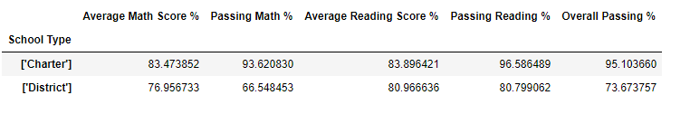

The average charter student has a much greater chance of passing than a student who goes to a district. This may be because most of the charter schools tend to have a smaller student body. All 7 small schools are charter schools and 1 out of 5 medium schools is a charter school as well. In addition, all the top performing schools are charter schools while all the bottom 5 schools are district schools.

